 |  | 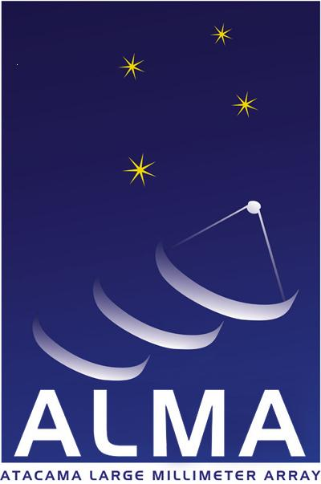 |  | 

CALL OF APPLICATIONS ALMA FUND 2008
FOR THE DEVELOPMENT OF CHILEAN ASTRONOMY
1. OVERVIEW
This program is developed within the general frame of the “Agreement of Scientific Collaboration for the Development of Chilean Astronomical Research ”, of October 28, 2003 and its subsequent modifications, between the Comisión Nacional de Investigación Científica y Tecnológica (CONICYT) and the European Southern Observatory (ESO), the Associated Universities Inc. (AUI), and the National Astronomical Observatory of Japan (NAOJ), executive organisms for the construction and operation of the Atacama Large Millimeter Array (ALMA).

The agreement establishes the creation of a fund for the development of the Chilean astronomy, which is to be administered by CONICYT in consultation with a Mixed Committee formed, in equal parts, by Chilean members and Alma’s executives.
2. PROGRAM GOALS
The Program is destined to support the development of the Chilean Astronomy and its preparation for the use of ALMA. This support may include, for example, hiring new professors, post doctorates and technicians; development and reinforcement of curriculum of postgraduates programs; initiatives of theoretical or technological nature, without exclusion of other initiatives of development of the national astronomy for which may be difficult to find alternative financing sources.
3. APPLICATION REQUIREMENTS
Proposals may be presented by non-profit public or private, national institutions developing or committed to develop astronomical research, Astronomy teaching, Astrophysics and/or astronomical instrumentation.
Proposals must be presented by the above mentioned institutions duly represented, and for the principal investigator of the project.

4. FUNDING
The maximum financing limit for Project is USD 100,000 (one hundred thousand U.S. dollars) per year of execution. A same institution is allowed to present more than one project.
5. DURATION OF PROJECTS
The projects proposed must be developed in a period not less than one year and not longer than two years.
6. APPLICATION DOCUMENTS
- Application Form (included) completed
- Description of the Project in the enclosed Application
- Letter of Commitment of the proposing Institution
- Curriculum Vitae of the Project Coordinator and the executing team.
- In case of joint presentations, identification of the corresponding taking part institutions and their respective letters of commitment
- Description of the equipment and materials required, including quotation and backing documents.
7. EVALUATION, Pre-selection AND AWARDS
The merit and relevancy evaluation of projects and of the suitability of its proponents will be done by external assessors designated by the ALMA-CONICYT Fund Committee. The principal factors to consider in the evaluation, in order of priority, are:
- Quality and relevancy of the proposal.
- Consistency between the objective and the requested funds in the proposal
- Academic trajectory of the responsible researcher and of the executing team.
- Ability to support the actions in time, beyond the financial support requested.

The ALMA-CONICYT Fund Committee, headed by the President of CONICYT, and formed by two astronomers of the Chilean Community appointed by CONICYT, four representatives designated by the executive entities of the ALMA Project and a representative of the Ministry of Foreign Affairs, will be the collegiate organ entrusted to check the evaluations of the proposals, and to choose the proposals to be awarded funding; and to modify –if necessary- the budgetary requested allocations and/or the time for execution.

CONICYT will issue the selection resolution based on the propositions made by the ALMA-CONICYT Fund Committee
8. APPLICATION DEADLINE
The date to submit the applications is due on Monday August 4, 2008 at 12:00 AM. The applications should be sent by Email to concursoalma@conicyt.cl in PDF or Word format. Furthermore, at the same date, 3 printed copies of all documentation should be forwarded to CONICYT offices, located in “Bernarda Morín 551, 1er Piso, Providencia, Santiago”. If the documentation is sent by mail or special courier, the stamp/seal must indicate as maximum date of dispatch August 4, 2008.
The applications should be presented in English. No application will be accepted if does not fulfil all the specifications established in these requirements or in the enclosed forms. Not fulfilling will be causal to declare the postulation out of the competition.
CONICYT reserves his right to interpret the sense and scope of these requirements in case of doubts and conflicts that may be caused by their contents and application.
For further information please contact: www.conicyt.cl/oirs
The documents and enclosed materials will not be returned to the applicants.
9. NOTIFICATION
Once the contest process' results have been decided, the final outcome, the results will be published on the Web page of CONICYT. The Project Coordinator of the selected applications will be also informed by mail.
10. AGREEMENTS
After the notification to the awarded proposals, the agreements should be issued. They will establish the rights and obligations of the parts, between CONICYT, the benefited institutions of the proposals and the Project Coordinator.
The direct beneficiary of the funds will be the applicant institution, which should submit and administer the corresponding bond of indemnity according to the clauses of the agreement. Furthermore, the institution should provide a physical space and contribute with infrastructure, personnel and support in all possible ways for the successful attainment of the project. Also, CONICYT will consider to the institution responsible of the opportune delivery of the advance’s reports and the completion report of the project execution, as well as submitting the corresponding expenses and caution of the transferred funds.
11. TRANSFERS
The transference of funds from CONICYT will be subject to the fulfilment of the following conditions:
11.1 entire processing of the resolution that approves the agreements,
11.2 deliver to CONICYT of the corresponding guarantee(s): bank guarantee, bearer promissory note or insurance policy of immediate execution, o equivalent document, for whose financing the ALMA-CONICYT Fund will provide an additional 3%, calculated on the total fund of the approved budget.
11.3 delivery and approval of the expenses accounts and technical reports of the projects, which period will be established in the agreements, and
11.4 CONICYT availability of funds.
12. PROJECTS COMPLETION
A project will be considered completed when the objectives and results have been fulfilled to satisfaction of CONICYT, the final report and the expenses account have been approved.
13. RESTRICTIONS
It is expressly established that the natural or juridical persons who maintain debts or other contractual obligations with CONICYT will not be able to apply and/or to take part in the present call for proposals.

Santiago, June 30, 2008

