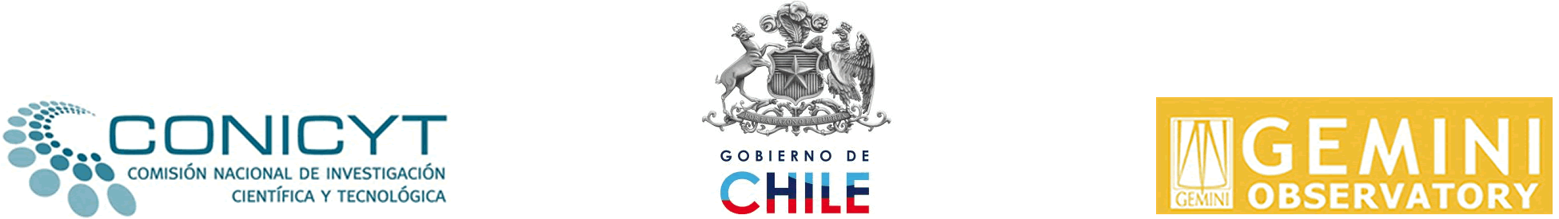

Gemini-CONICYT Fund
For the Development of Astronomy and Related Sciences
2010 CALL FOR PROPOSALS

APPLICATION FORM

CHECKLIST
Documents to be submitted with the application form

INSTITUTIONAL APPLICATIONS / POSTULACIONES INSTITUCIONALES |  | Mark with √
Complete application form
Institutional commitment and/or sponsorship Letter.
For senior positions must be signed by Dean or Rector
Curriculum Vitae of the Project Coordinator and the executing team.
Include list of last 5 years publications
In case of joint applications, identification of the participating institutions
Description of the required equipment and materials, including supporting quotes and documentation

APPLICATION OF INDIVIDUALS / POSTULACIONES PERSONAS NATURALES |  | Mark with √
Application form
Curriculum Vitae. Include list of last 5 years publications.
Letter of of the national or foreign academic and/or research institution where the internship and/or visit will be conducted





I. GENERAL INFORMATION

Type of application Institutional _____ Individual _____

1. Name of the Project

2. Total amount Requested to CONICYT | USD | 3. Project Duration (in YEARS)
(Maximum 2 YEARS)

3. Project coordinator information
Names | Last names (Mother’s Maiden Name) | Academic Degree | Institution / year
Institution | Faculty | Department | Position
Region

4. Institution and responsible authority information
Name of the Head of the Department/Entity |  | Position
Institution | Faculty | Department

5. Indicate the MAIN area of application of this project (ONLY ONE). Mark with √

Scientific project |  | Instrumentation project |  | Teaching and outreach

Other |  | Specify:
II. PROJECT INFORMATION

1. Proposal Summary. (maximum of 200 words)

2. Description of the proposal;, ,.

General goal:

Specific goals:

Work plan:

III. RELATED OR COMPLEMENTARY INFORMATION

1. Related and complementary projects approved by other national or international sources. (Specify the extent and differences with the current proposal).

2. Relation of the proposal with the Faculty's strategic plan

3. Project's relevant participants and alliances (if applicable). Institutions, technical teams or specialists and the role of each one of them.

4. Continuity. Technical and financial perspectives of continuity and/or self-financing of the activities, after the completion of the Project.

5. Information about the Participating Academic Program(s) only proposals that seek to fund post-graduate students

Name of the Academic Program

Academic Program(s) Regime (Part-time or Full-time)

Year in which it started* | No. of Graduated Students * N° de Alumnos graduados*
Total No. of Currently Enrolled Students | No. of Freshmen in 2007*
* provide details for each one of the participating programs

Accreditation of postgraduate programs
Accredited |  | Accredit. Inst. |  | Year Año
In process |  | Accredit. Inst |  | Application Date
.

IV. BUDGET INFORMATION

1. Budget* (Indicate the project's activities)
Actions | Year 1 | Year 2 | TOTAL USD
Teaching Programs in Regional Universities
Organization of meetings, seminars and specialized courses
Use of opportunities offered by international observatories
Sabbatical internships of foreign faculty
Sabbatical internships of Chilean faculty
Research visits
Insertion of high-level, “senior” researchers
Post-doctorate positions in chilean universities
Acquisition of minor scientific equipment, software and bibliography
Provision of minor infrastructure
Master or doctorate grants
Support grants for performing doctoral theses
Other (Specify)

TOTAL USD requested to CONICYT

2. Budget breakdown by actions. Detail all the items included in each of the defined actions.
Action N° 1 | Amount | Unit Value USD | Total in USD
Action N° 2 | Amount | Unit Value USD | Total in USD
Action N° 3 | Amount | Unit Value USD | Total in USD
(Add rows if necessary)

