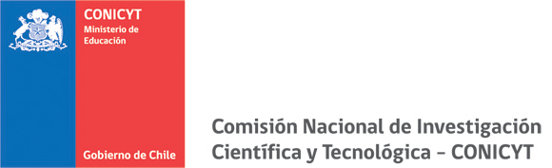

RESEARCH PROPOSAL (maximum 20 pages)
The proposal must include:
- Description of the priority area to be addressed, and its scientific contribution.
- Research proposal, including research lines, questions, hypothesis, objectives, methodologies and expected results.
- Actions leading to association between Center´s researchers and their main research lines
- Advanced Human Capital Training
- Strategy and action to dissemination outreach and transfer (knowledge and technologies) to the society and the public/private sector.

Collaboration Strategy (maximum 2 pages)
- Actions leading to establish national collaboration networks.
- Actions leading to establish international collaboration networks.

