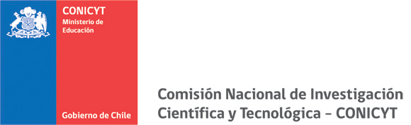

CALL FOR PROPOSALS SUPPORTING THE DEVELOPMENT OF RESEARCH PROJECTS
BETWEEN CHILE AND THE UNITED STATES
2013
PROJECT PLAN

Name of Lead Researcher in Chile

Project Title

Each Project Formulation proposal must contain the following information:

- SUMMARY: (Maximum length: 1 page)
A clear summarised description of: objectives, methodology and expected results. The project summary section will assist in our assessment of your application. Summaries of selected projects may be published in the CONICYT website.

- WORKING HYPOTHESIS: (Maximum length: 1 page)
Describe and explain the working hypothesis/hypotheses and any questions that will orientate and guide the research you intend to carry out.

- OBJECTIVES: (Maximum length: 1 page)
Specify the objectives of your research (general and specific).

METHODOLOGY: (Maximum length: 3 pages)
Describe the methods you intend to employ, justifying your choice.

- THEORETICAL FRAMEWORK AND BIBLIOPGRAPHY: (Maximum length: 5 pages):
This section should include an overall presentation of the problem paying particular attention to specific aspects or areas for development, also indicating the approaches currently used in the study of your research topic, as well as the theoretical background and related bibliographical analysis. This section should also make reference to the project’s working hypothesis. You may also indicate here, if deemed necessary, any other information you feel may be relevant to the assessment of this application.

WORK PLAN: (Maximum length: 1 page)
In relation to the objectives stated above, outline the stages of your research and the activities planned for each year of project implementation, including a Gantt chart for the overall project.

- EXPECTED RESULTS AND IMPACT: (Maximum length: 3 pages)

- ANNEXES:
All Applicants must ensure that any relevant annexes and required documentation is uploaded.

