CONICYT

CONTESTS OF REGIONAL PROGRAMS STIC/MATH AMSUD – CONICYT CALL 2019

user manual – online application

INDEX

ENTRY TO THE SYSTEM 2

SELECTION CONTEST 4

START APPLICATION 6

I.- Selection GENERAL MENU 6

II.- Tab INFORMATION 7

III.- Tab BACKGROUND 8

IV.- Tab INSTITUTION 10
V.- Tab WORK TEAM 13
VI.- Tab FORMULATION 16
VII.- Tab ANNEXES 16
VII.- Tab REVIEW/SUBMISSION 17

Below are the instructions to enter the online application indicating the fields to fill in each section and their meaning.

OVERALL CONSIDERATIONS

You can submit the application both in Spanish or English.

ENTRY TO THE SYSTEM

Create Account

To create an account, you must enter the following link https://auth.conicyt.cl and then select the “Continue” button (Fig.1).
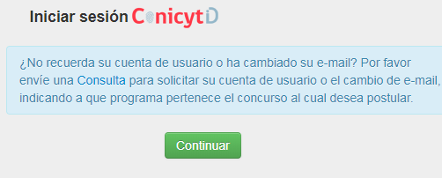

Figure 1.

Then you must select the "create your account" button (Fig.2). Then you must complete the fields requested in the form and once you have done this, you must press the “Following” button.
You have to create your own key: it must contain at least eight characters and include numbers, letters and be free of consecutive identical characters.
Then you will receive an email with the instructions to validate your account.

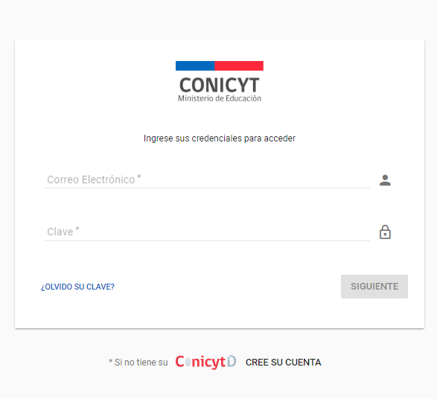

Figure 2.

Recover Key

If you do not remember your password, you can recover it by selecting the option "Forgot your password?" (Fig 3.)

Figure 3.

Later a new window will be displayed, in which you must enter your mail and then press the "Continue" button (Fig. 4). The new password will be sent to the added email address.
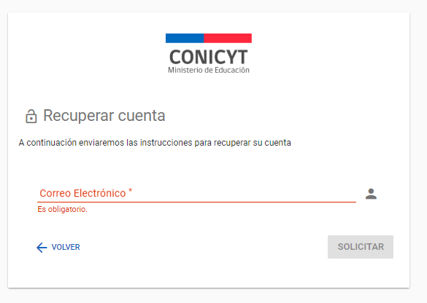
Figure 4.

SELECTION CONTEST

When entering the System, you will find the following four sections, as shown below, to access the contests you must choose the "Applicant" section and select the option "Create a new application" (Fig 5).

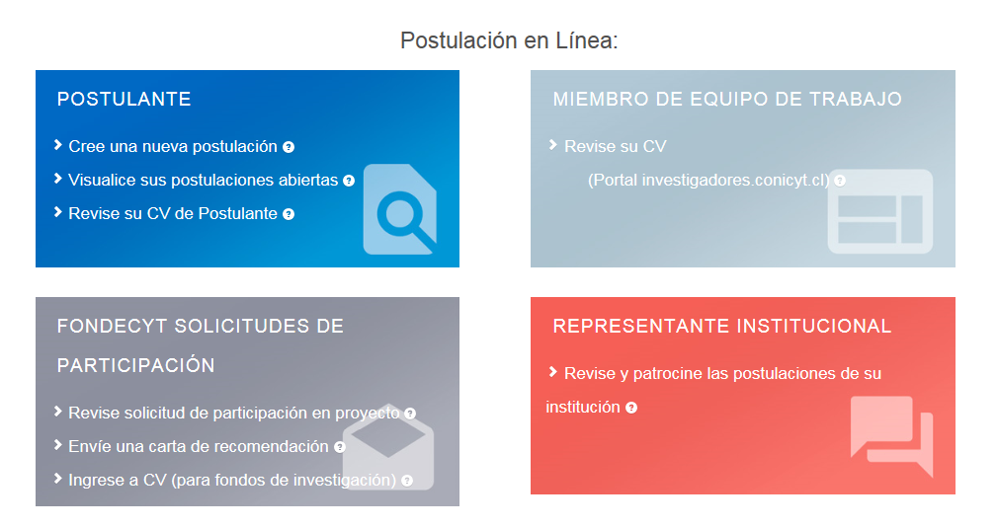
Figure 5.

You can view all the contests that are published. To apply, you must select the Contest "CONTEST OF THE REGIONAL PROGRAM STIC / AMSUD or MATH / AMSUD - CONICYT CALL 2019” as shown in (Fig.6).

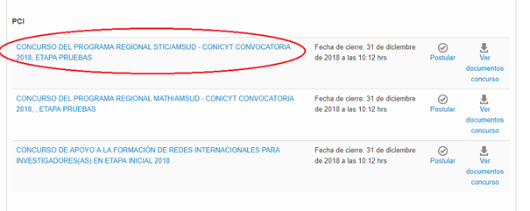

Figure 6.

Then select the “Start Application” button.

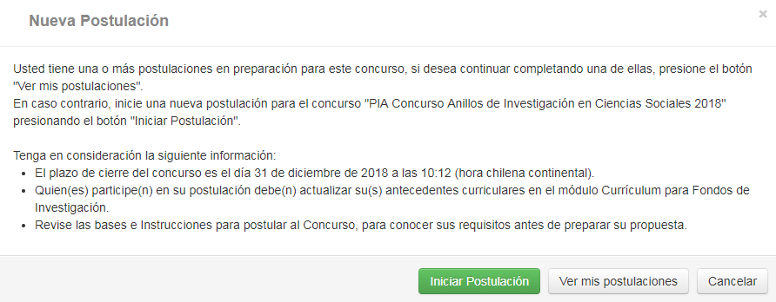

Figure 7.

Please, after having entered your data in each section, when finished, press the "Save" button and go to the next tab.

START APPLICATION

Selection GENERAL MENU
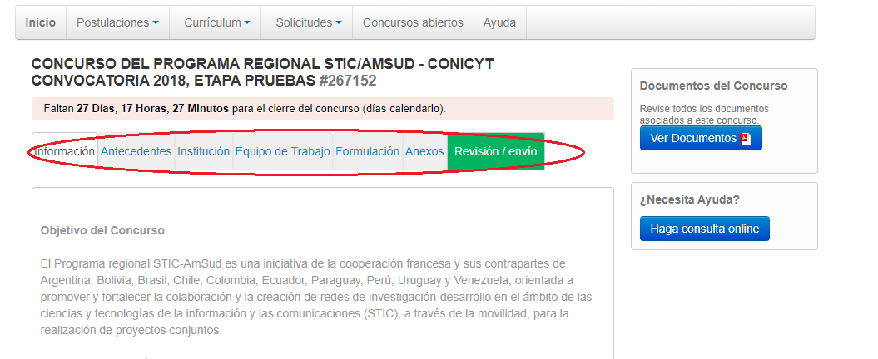

Figure 8.

In the lower menu are available the different tabs to complete during your application, these are: Information, Background, Institution, Work Team, Formulation, Annexes and Review / Submission.

Tab “INFORMATION”

Figure 9.

In this section are the objectives of the Contest, to whom it is addressed and the recommendations to the applicants.

You must accept the terms and conditions, as indicated below.
Figure 10.

When finished, press the "Save" button and go to the "Background" top tab.

Tab “BACKGROUND”

Figure 11.

In this section you will have to fill out the general identification of the project, as well as include a summary of it.

Section : “Project Identification”

1. Title of the Proposal.

In this Contest, this field corresponds to the Title of the proposal. We suggest you to use an original name, in order to avoid coincidences with previous projects. The title of the proposal must be exactly the same in all the forms submitted to this contest and must be in English.

2. Keywords.

When you start to write a word (which must be in ENGLISH language), the System by default will offer you keywords between which you should select the closest to your subject. The list of keywords that the System offers corresponds to those already entered in the scientific articles indexed in WOS and SCOPUS. Once the keyword is found, you must select it and then press the “Add +” button.

3. Duration of the Project.

These projects have a pre-established duration of two years, that is 24 months. The International Coordinator will send the project’s ongoing report to the Secretariat before October 1st, 2019. At the end of the first year of execution, and according to the ongoing report, the Steering Committee will decide on the delivery of financial resources for the second year.

4. Project type

You must select the STIC AmSud option for the STIC AmSud Regional Contest and the MATH AmSud option for the MATH AmSud Regional Contest.

5. Main disciplines

Select the main disciplines associated with the study. To incorporate Main Discipline, you must select the option corresponding to the last level and then press the 'Add +' button.

6. OECD Disciplines

Select the OECD discipline(s) associated with the study. To incorporate OCDE Discipline, you must select the option corresponding to the last level and then press the 'Add +' button.

7. Impact of cooperation

Select in the proposed list the impact of cooperation associated with the study.

When finished, press the "Save" button and move to the top tab.

Section: Summary and Objectives
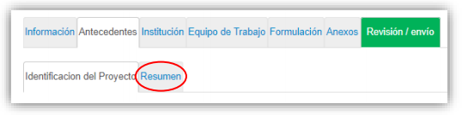
Figure 12.
In this section you must enter the summary of the project, for which you will have a maximum of 2000 characters.
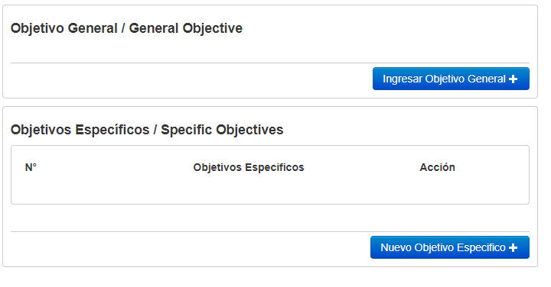
Figure 13.

You must also enter 1) the general objective (max 500 characters) and 2) the specific objectives (max 500 characters) in this section.

Tab “Institution”
Figure 14.

Section: “Institution”

In this section you must add the Participating Institution.

By pressing the "Add Institution +" button (Fig. 15), a box will appear (Fig. 16) that will allow adding the name of the Institution.

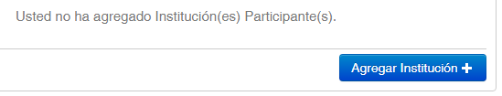
Figure 15.

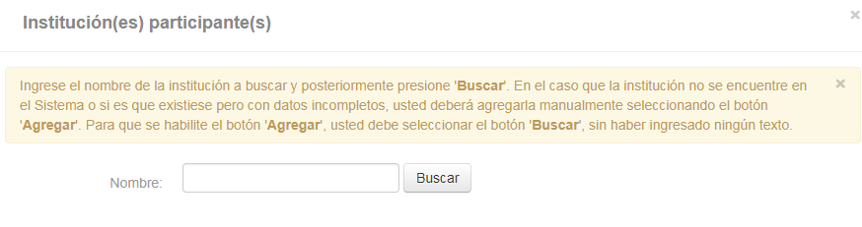
Figure 16.

When entering the name of the institution you wish to add and pressing the "Search" button, one or more matches will appear, depending on the records of institutions available in the System database. Select the result that matches the Institution you want to add as shown in (Fig.17).

To select the category of the institution, when entering it you must select the field "Type of institution" of the form and choose the category, this can be "South American Institution" or "French Institution" (Fig.17).

In this section you must add the participating institutions of the project to which all the team members of South America and France belong.

Remember that to guarantee the regional nature of the project, you must include at least two South American researchers and a French researcher.

The institution to which the responsible researcher for South America and France belongs must be identified.

In the case of entering an institution that does not appear in the list displayed by the system, it can be added manually.

The RUT and the RUN are Chilean identification numbers that are valid only for the application of Chilean universities and researchers.

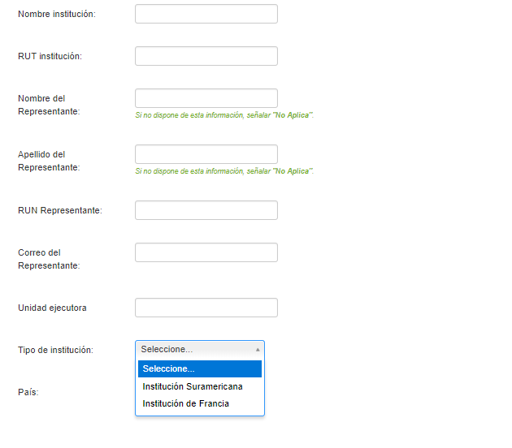
Figure 17.

WHEN YOU ENTER THE INSTITUTION, THE SYSTEM WILL SUGGEST IN THE FIELD "EXECUTING UNIT", ONE OR MORE FACULTIES AND / OR CENTERS.

If the list of institutions does not include the one you wish to add, you must add it manually by selecting the "Add" button (Fig. 18).
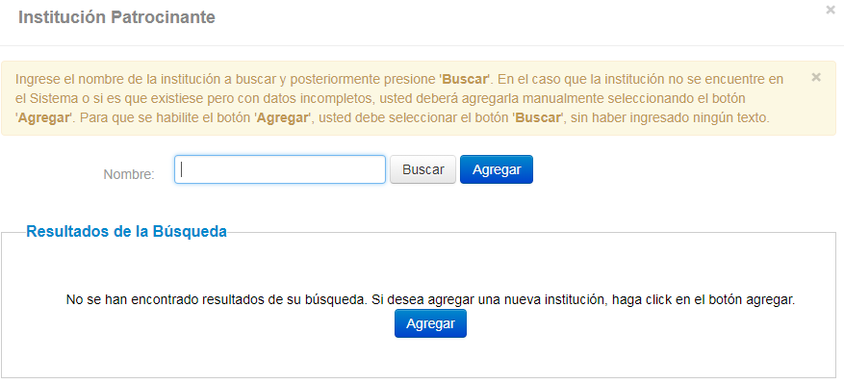

Figure 18.

By clicking on the "Add" button, a box will appear with fields to complete such as: name of the Institution, RUT, name of the Legal Representative, type of institution, among others (Fig. 19).

You must perform this operation as many times as necessary. Remember to save the changes by pressing the "Save" button.

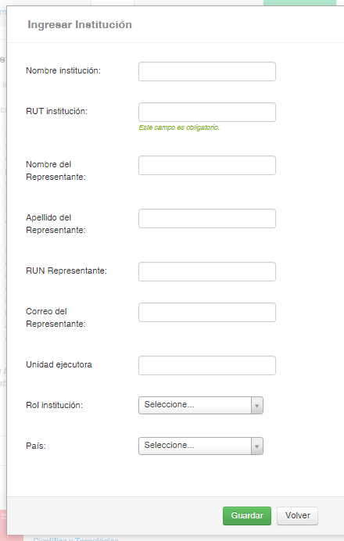

Figure 19.

Tab “Work Team”

Figure 20.

In this section you must enter the following categories (Fig. 20):

International Project Coordinator: Enter the name and experience of the international project coordinator here. There should only be one international project coordinator in the team.

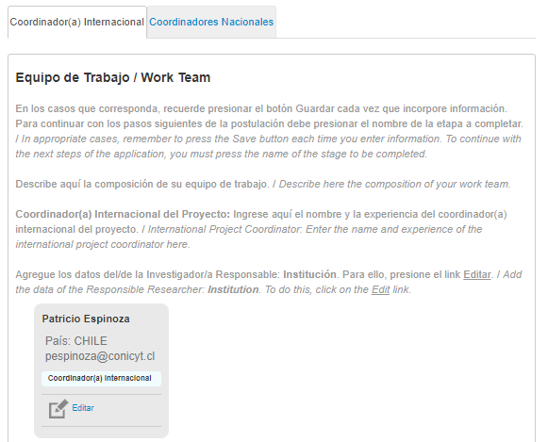

Figure 21.

National Project Coordinators (minimum 2): You must add at least two national coordinators, in addition to the international coordinator. The international coordinator can also be the national coordinator of its own country. (Fig. 21)

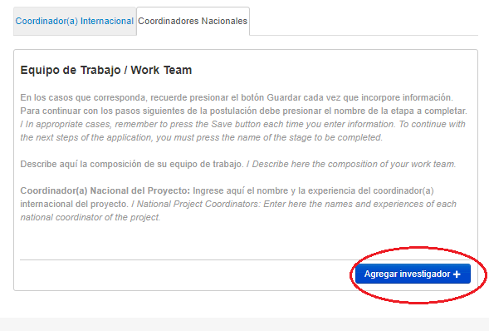

Figure 22.

To add Coordinators to the proposal, you must click the "Add researcher +" button. (Fig. 22) Pressing it will open a new window (Fig. 23), which will allow you entering information about the Investigator.
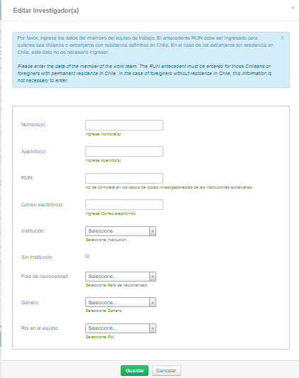

Figure 23.

When completing the missing information, press the "Save" button.

Tab “Formulation”

Figure 24.

In this section you must attach the following documents:

• Proposal form (PDF format; Maximum size 10 MB). REQUIRED.
• Proposed evaluators (PDF format, Maximum size 10 MB). REQUIRED.

To transform the files from .doc or .docx format to .pdf, you must use the following programs:

Foxit Reader: http://www.foxitsoftware.com/downloads/
PDF Creator: http://www.pdfforge.org/download o http://sourceforge.net/projects/pdfcreator/

- Tab “Annexes”

Figure 25.

Curriculums (PDF format; Maximum size 10 MB). REQUIRED.

Engagement Letter: (PDF format, Maximum size 10 MB). OPTIONAL.

- Tab “Review/Submission”
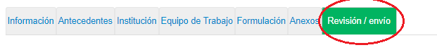
Figure 26.

By pressing the "Review / Submission" button (Fig. 26), the System will verify if the mandatory information was completed and if the documents were loaded. This validation will not verify the content of the documents, but only if the loading of the mandatory files has been done.

Step 1. Verify

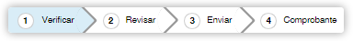
Figure 27.

In this step, the System will verify the completeness of the online application, indicating what is missing in order to send the application. To complete missing information, you must press the "Edit" button.

If after pressing "Revision / Submission", the System indicates that your application is with all your information and without observations, you must press the "Continue" button. When doing this, the following table will appear:
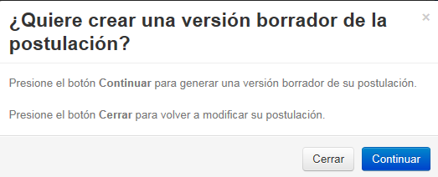
Figure 28.

You will have 2 alternatives: 1) "Close", in which case you will return to the "Verify" step, being able to modify your application without seeing a complete draft of it, and 2) "Continue", which will allow you to access the "Revise" step.
Figure 29.

Step 2. Revise

In this step, the System will allow you to review the added information. When selecting the option "See Postulation" of (Fig. 30), a new window will open in which you can review the information you added by navigating in the Menu that appears on the right side of the screen.
Figure 30.

The "Continue" button will allow you to advance to the "Send" step.

Step 3. Send

To submit the application, you must read and accept the conditions contained in the Sworn Statement set out in the System, adhere to the Declaration of Singapore about the integrity of the investigation and enter your password. Only then you can press the "Send Postulation" button (Fig. 31). Remember that once your application is submitted, it will no longer be possible to make changes.

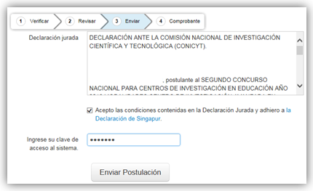
Figure 31.

Step 4. Receipt

Once your application has been submitted, a message indicating the application number, date and hour it was made will appear on the screen (Fig. 32). You can access the Certificate of Application, the Affidavit of Truth, as well as a copy of the submitted application.

Figure 32.

After submitting your application, the System will send you a confirmation message via email, stating that your application is received by CONICYT.

