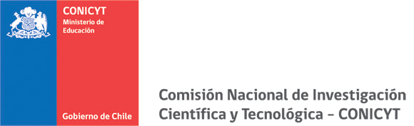

PROGRAMA DE INVESTIGACION ASOCIATIVA
RESEARCH TEAM PROJECTS IN SCIENCE AND TECHNOLOGY, SOCIAL SCIENCES AND HUMANITES, ANTARCTIC SCIENCE

PROJECT DESCRIPTION (Maximum extension 20 pages-not including Apppendices or file of less

than 8Mb). To load transform to pdf

Please follow guidelines, application instructions and application form for details

Research background, objectives and activities

Human capital training and formation

International Cooperation

Dissemination of results and knowledge transfer to non-academic environments.
National Networks (Only for projects participating in the national tender process for Research Team Projects in Social Sciences and Humanities)

Application and / or of knowledge transfer and impact on Public Policy (Only for projects participating in the national tender process for Research Team Projects in Social Sciences and Humanities in Public Policy Innovation mode.

References

